Lesson Element

LDS – Starter Activities (set 2)

Instructions and answers for teachers
These instructions cover the student activities section which can be found starting on page 7.
This Lesson Element supports OCR AS and A Level Mathematics A.
When distributing the activities to the students either as a printed copy or as a Word file you will need to remove the teacher instructions section. Please note that a selection of prompt questions has been given for each activity. You can use all of them, some of them, or add extras as appropriate to your students and intended delivery. Some of the activities include data from a specific region. You may use them as they are, or create similar diagrams or charts from the data for your region if you prefer.

Introduction

Resources for ‘Using the Large Data Set (LDS)’
The large data set (LDS) is a pre-released set or sets of data that should be used as teaching material throughout the AS and A Level Mathematics course. This data set is available on the OCR website, under ‘Assessment Materials’.
The purpose of the LDS is that learners experience working with real data in the classroom and explore this data using appropriate technology. It is principally intended to enrich the teaching and learning of statistics, through which learners will become familiar with the context and main features of the data. This resource can be used to embed the OCR large data set (LDS) in the teaching and learning of statistics in the new Maths AS/A Level.
Please note that this version of the resource is currently being trialled by teachers in the classroom. It is intended that any feedback provided will inform the revising and improvement of this resource. If you would like to provide feedback click on ‘Like’ or ‘Dislike’ and when the email template pops up please add your comments.

DISCLAIMER
This resource was designed using the most up to date information from the specification at the time it was published. Specifications are updated over time, which means there may be contradictions between the resource and the specification, therefore please use the information on the latest specification at all times. If you do notice a discrepancy please contact us on the following email address: resources.feedback@ocr.org.uk

Resource overview | This resource consists of the second set of short starter activities on data presentation and interpretation using data from the Large Data Set.
Activities covered | A mix of short discussion activities:  6. Small multiples - histograms  7. Types of Local Authority  8. What difference does 10 years make?  9. Mean - Median

Rationale
The Large Data Set is primarily intended to be investigated using techniques from 2.02 Data Presentation and Interpretation. Part of the requirement is that students develop familiarity with the terminology and contexts of the Large Data Set. This is best developed slowly over time with short activities; this resource shows some of the ways in which this can be done through short starter activities which can be used at the beginning of any statistics lesson. Essentially this is a series of ‘What’s the same, what’s different?’ tasks in a variety of contexts aimed at exploratory data analysis, ie using graphs as tools for looking at data and seeing if it suggests any patterns or relationships, rather than using the data to confirm a previously stated hypothesis.
These activities can be presented via a projector or on paper. They do not require students to use technology at all; the intention is to introduce some of the contexts, terminology and ideas without technological barriers and in a way which focusses the time spent on interpretation and discussion.

Assumed knowledge
For each activity, it might be helpful for students to be familiar with any measures and forms of presentation, but these activities can work as an introduction to some of the ideas within them, so no assumed knowledge is necessary. For context it might be useful to have copies of the full map of Local Authorities and Unitary Authorities which is available here https://www.arcgis.com/sharing/rest/content/items/6df8fba849ba4226a8ec935752c5f195/data

Teacher notes
You can present any of these activities as a quick look at some aspect of data presentation and interpretation using the Large Data Set. You should encourage your students to make general comparisons and observations in any of these activities, ie not to restrict themselves to the prompt questions that you’ve handed out. All of the activities will work very well for a 10 minute starter, but they can all be extended into full lessons by allowing 10 minutes for individual or group investigation, followed by an open discussion of their findings and hypotheses. Students can then return to the given information to follow up others’ suggestions, to the Large Data Set itself armed with specific questions, to the Large Data Set to produce further graphs, or to the internet to look for evidence of some of their conclusions.
The key message to get across is that these activities are all about informal inference, ie we are looking for patterns, or points of interest, and suggesting what the causes of these might be, or what they might tell us about local authorities. It is good to know whether or not suggestions are correct, and to remember types of relationships and causes, but students are not required to collect specific knowledge about particular regions or local authorities through their work with the Large Data Set.
Starter activity 6: Small multiples – Histograms
This activity uses 10 histograms, one for each Region of England and Wales, showing the age structure in 2011. The axes have the same scales and the area shows frequency rather than relative frequency so as to preserve the information about the relative sizes of population in the regions.
The prompts are fairly open, but you might like to be more specific, for example to ask students to identify the regions which appear to be where people move to on retirement, ie the South West, Wales and North West, rather than the more open question about movement.
Some points of interest
- Frequency was used rather than relative frequency. This preserves the extra dimension of total population, but at what cost? It is much harder to make distributional comparisons between, say, Wales and London because our reading is distorted by the scale.
- London has a very clearly higher proportion of 25 to 29 year olds compared to the general population. Presumably this is to do with movement of graduates to where the jobs are.
- However, there is a much steeper decline in London, with this region being the only one in which 30 to 44 years is significantly higher than 45 to 60 years.
- Any conclusions about cause made by students should be non-assertive, for example it could simply be that there were a lot of children born in London in the late eighties, which accounts for the peak. We can be assertive about the fact that London has this peak, but not why; this is an important distinction between deduction and inference which is only possible to make because this is population data.
- There seem to be an unusually high number of very old people in the South East, and relatively few in the North West. Is this the case, or is it distorted by the choice of frequency rather than relative frequency? We could change the graphs to relative frequency to make these sorts of comparisons more carefully. This is an exploratory data analysis type of technique, spotting a possible pattern and then deciding on a different form of graphical representation to make a better comparison.
- The fine detail for young people is very interesting in these histograms. All show a larger cohort of children coming through in the 0 to 4 year old class (how old are they now?), and a previous large cohort in the 18 to 19 and 20 to 24 year old classes.
In the 2001 data this latter cohort appears earlier in the data, but in the 2017 data (we can assume), it should show later.
- The larger classes for 30 to 60 year olds don’t show this sort of variation. That doesn’t mean it isn’t there, only that if it is it has been smoothed out by the grouping.
Starter activity 7: Types of local authority
The intention behind this activity is to give students a starting point for thinking about the broad differences between types of local authority, the names that the categories have and the characteristics that apply to those local authorities in a general or aggregate sense.
The five types: E06 Unitary authority in England, E07 Non-metropolitan district in England, E08 Metropolitan borough in England, E09 London borough and W06 Unitary authority in Wales are described briefly on the student sheet.
Important note: These types are mentioned in the metadata sheet, but students are not expected to know any more than the brief sort of description given on the student sheet and some of the general trends as outlined below. This activity would be good either for introducing the different types or as a reminder later in the course when some of the characteristics may have been noticed through other work on the LDS.
The types are in numerical order on the graph, so beware of the guessing student; the key thing here is to be able to explain why you have made your choices and/or to discuss your choices.
Some points of interest:
- The obvious standout is the purple set which has a very high proportion of UMLT use and very low car use. This is the London Boroughs.
- The next set in terms of use of UMLT, Bus and Taxi is the green group which is the Metropolitan boroughs. It may be confusing that the non-Metropolitan boroughs (red group) has a higher proportion of train use, but this is to do more with distance travelled to work than the presence of infrastructure.
- The Unitary Authorities in England and Wales are very hard to tell apart unless you know that the Welsh have a particularly low proportion of cycling and high use of cars. This is the defining difference for these two types, making the Welsh Unitary Authorities Blue and the English Yellow.
- This is a very good visualisation for why the London Boroughs have their own category. Within Methods of Travel at least they behave in a very different way to the rest of the country.
Starter activity 8: Age structure – what difference does 10 years make?
This activity is based around two histograms, one for the age structure of London in 2001 and one for the age structure of London in 2011. The main purpose of the activity is to get students thinking about the way in which the cohorts move within the age structure across a 10 year gap, ie that the 0-4 year old class in 2001 is the 10-14 year old class in 2011. They should, by the end of the activity have appreciated that equivalent classes are not identical people, since people will have moved into or out of the Region, or will have died, during the period.
Some points of interest:
- Due to the unequal class widths, some cohorts are easily comparable between 2001 and 2011, but others need a certain amount of amalgamation and estimation. Encourage your students to do this roughly on the diagrams. This is not an exercise in precision; they can go the LDS to confirm patterns spotted afterwards.
- The population over 65 is pretty much identical. This implies no difference in behaviour for these cohorts. It might indicate that there is little change in life expectancy, but it might also be explained by longer life expectancy combined with a higher proportion of these cohorts is moving outside of London.
- Most of the growth in population is in the 20 to 45 year old age class, so it is interesting to note the other major increase in the 0 to 4 and 5 to 7 year old classes …
- Note that the 0 to 9 year old population in 2001 is very similar to that 10 to 19 year old population in 2011.
- The 10-14 year old class in 2001 is the 20-24 year old class in 2011, ie more or less the class in which you will find the student population. This class has a very large increase, about 200,000 people, which represents the very large population moving into London after school for university, college, work etc. Estimating the 200,000 figure from the histograms is an interesting exercise in itself!
- Note that this student population has increased between 2001 and 2011, but not by as much as the 25 to 29 year old population.

Starter activity 9: Mean - Median
This activity looks at the Mean – Median measure. Note that this is not the nonparametric skew, since it doesn’t include the divisor of standard deviation, nor is it a measure of skew that is part of the specification. It is simply intended to be an investigation of the mean and median, what can be inferred about the shape of a distribution from the measure, and its application as an exploratory data analysis tool in the context of the Large Data Set.
It should also be noted that this measure of skew does not necessarily have the same sign as the modern definition of skewness, so one should be careful not to conflate the two ideas. It does in these particular cases, but the sign of this measure can be flipped by long tails, multimodal distributions etc.
Students should be encouraged to follow up their hunches by exploring these Local Authorities in the LDS to check the distribution, and online to check any inference made about the nature of the Local Authority.
Some points of interest:
- The negative value is definitely associated with areas that have high proportions of older age classes, and the positive value with younger age classes.
- It is very tempting to categorise the negative group as place people retire to, which is certainly true in many cases, but not necessarily all.
- It is also tempting to categorise the positive group as places with large university populations, which is the case.
- The trap is to assume that the five with no difference have symmetric distributions. Of course the measure doesn’t really say anything about the “shape” of the distribution only the “balance” between the two halves, which could come from a neatly skewed distribution, but could also come from other effects.
This would be a good activity to use for flipped learning, with students who have access to suitable IT and have the necessary skills, as a starter for a self-directed exploratory task.

OCR Resources: the small print
OCR’s resources are provided to support the teaching of OCR specifications, but in no way constitute an endorsed teaching method that is required by the Board, and the decision to use them lies with the individual teacher. Whilst every effort is made to ensure the accuracy of the content, OCR cannot be held responsible for any errors or omissions within these resources.
© OCR 2017 - This resource may be freely copied and distributed, as long as the OCR logo and this message remain intact and OCR is acknowledged as the originator of this work.
OCR acknowledges the use of the following content: n/a
Please get in touch if you want to discuss the accessibility of resources we offer to support delivery of our qualifications: resources.feedback@ocr.org.uk
We’d like to know your view on the resources we produce. By clicking on ‘Like’ or ‘Dislike’ you can help us to ensure that our resources work for you. When the email template pops up please add additional comments if you wish and then just click ‘Send’. Thank you.
If you do not currently offer this OCR qualification but would like to do so, please complete the Expression of Interest Form which can be found here: www.ocr.org.uk/expression-of-interest
Looking for a resource? There is now a quick and easy search tool to help find free resources for your qualification:
www.ocr.org.uk/i-want-to/find-resources/

Large Data Set Starter Activity 6

Small multiples – Histograms
The small multiples on the next page are histograms of the Age Structures of the Regions of England and Wales in 2011.
Take a moment to look at them for similarities and differences.
- Why are the graphs all different sizes?
- Which region or regions stand out as having an unusual distribution of ages?
- What do you think might be the cause of this?
- Can you see any indication of population movements based on age? Do the graphs suggest that there are particular regions that people move to or from at particular ages?
- Are your answers to the above prompts definitely true, or possibly true?
- Are this data populations or samples? Does it make any difference?
- These data are for 2011. How would they look different for 2001, or for this year?

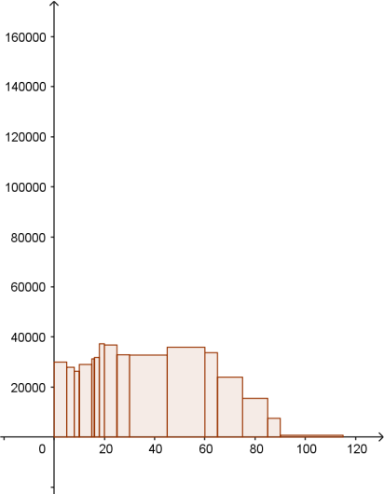
North West
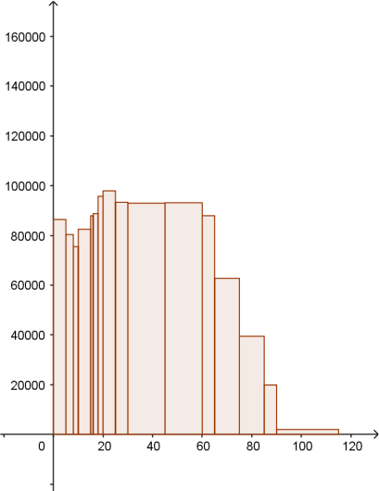
North East
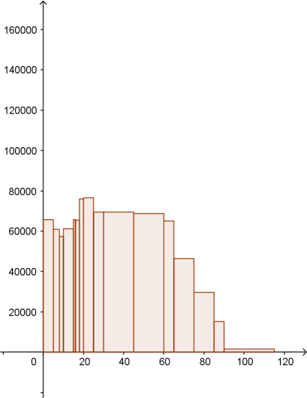
Yorkshire
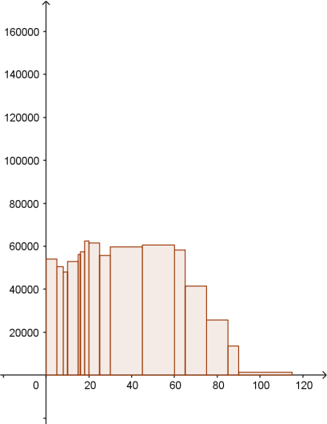
East Midlands
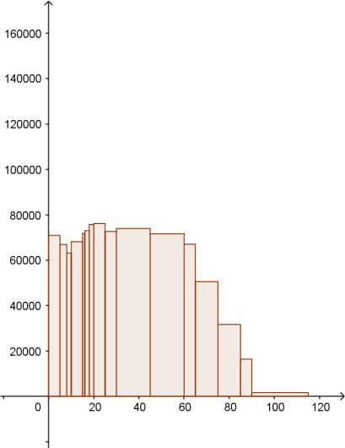
West Midlands
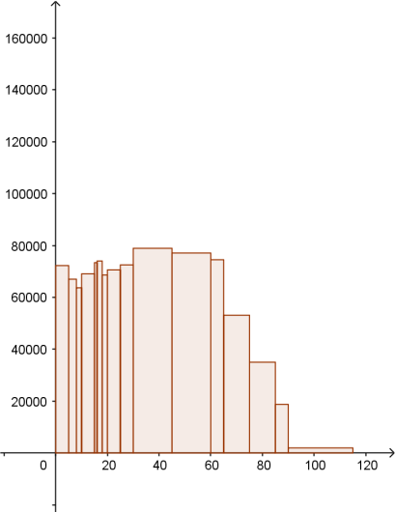
East of England
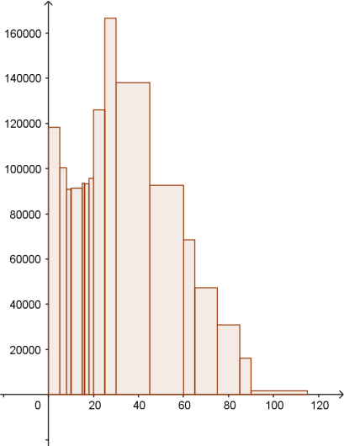
London
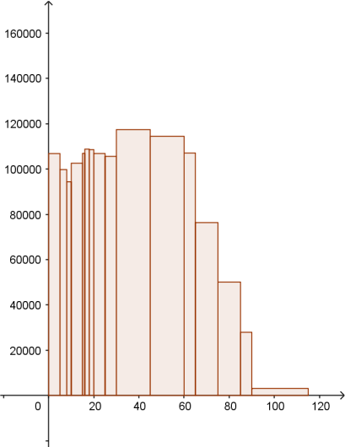
South East
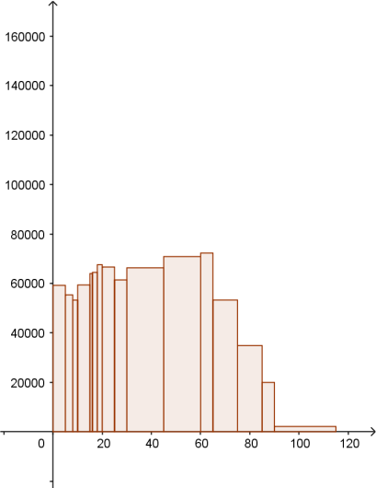
South West
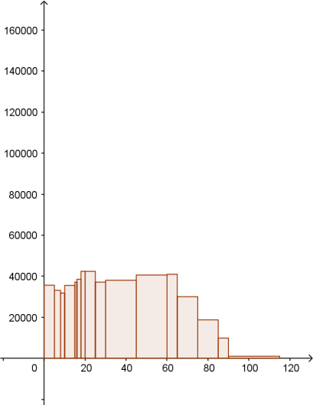
Wales

Large Data Set Starter Activity 7

Types of local authority
The Large Data Set includes data from all of the local authorities in England in 2001 and 2011. There are five different types of local authority, categorised by the way that their administration works. You don’t need to know about how this is done, but you do need to have a feel for some of the broad differences between the five types. Each of the types has its own three symbol code which you can find at the beginning of a given Local Authority’s Geography Code. For example Shropshire has the code E06000051 so it is a Unitary Authority.
E06: Unitary authority in England
Larger than a normal Local Authority, and generally more rural. These were created by amalgamating old, smaller, Local Authorities and often represent whole counties.
E07: Non-metropolitan district in England
These are the "normal" Local Authorities, so they are not heavily urbanised, particularly rural or very small.
E08: Metropolitan borough in England
These are heavily urbanised Local Authorities, often in the centre of large cities.
E09: London borough
The London Boroughs are a category on their own to reflect their particular character.
W06: Unitary authority in Wales
All of the Local Authorities in Wales are Unitary Authorities, ie they operate in similar ways to those in E06. However, note that some of these, such as Cardiff and Newport are more urbanised than that comparison suggests, so W06 includes Local Authorities with a wide range of characteristics.

The task
On the next page is a stacked bar chart showing the proportions of people living in each type of Local Authority who travel to work in each of the 10 ways in the LDS.
- Can you decide which colour represents which type of Local Authority?
- How did you decide?
- What general patterns or features have you noticed?

- Boxplot of proportions of method of travel by Type of Local Authority in 2011.
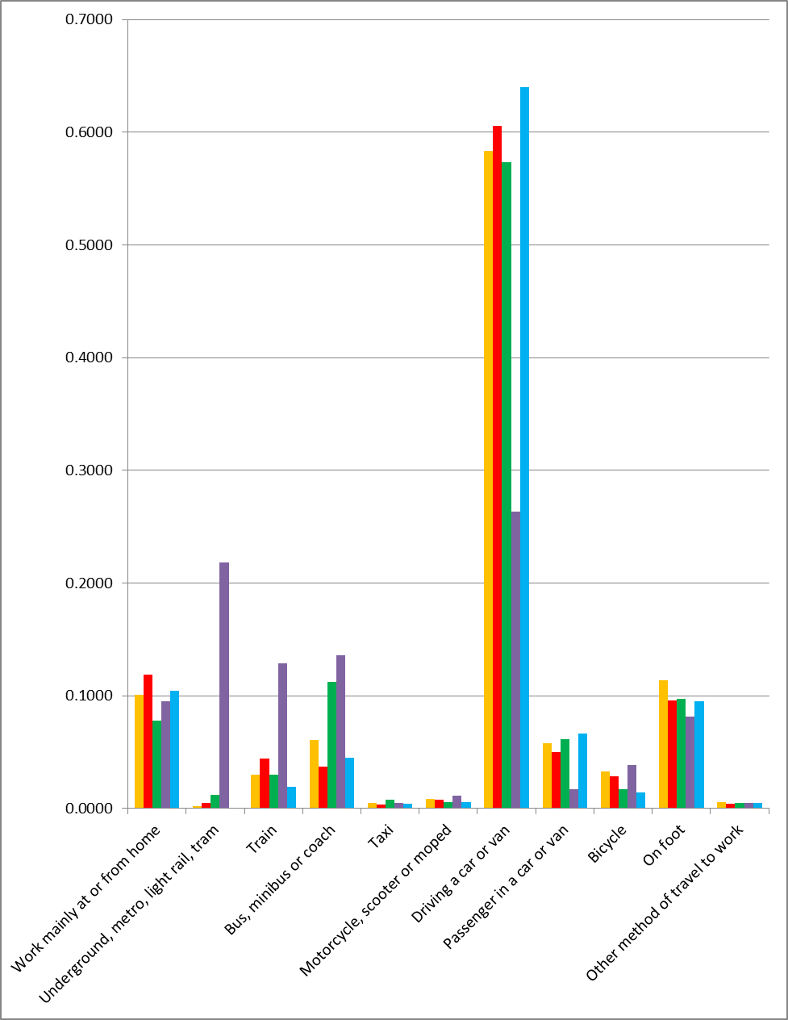

Large Data Set Starter Activity 8

Age structure – What difference does 10 years make?
On the next page are two histograms showing the age structure in the London Region in 2001 and in 2011.
To allow for comparison across the decade, the vertical axis is frequency density, so that area represents frequency for each class.

- What do you notice in terms of the shapes of the two distributions
- Remembering that these data are 10 years apart, which classes of the 2001 population and 2011 population represent the same people? Are they actually the same people? Which appear to have increased or decreased? Can you explain any pattern you see?
- There has been a large increase in London’s population in the 10 year period. Which age classes have increased?

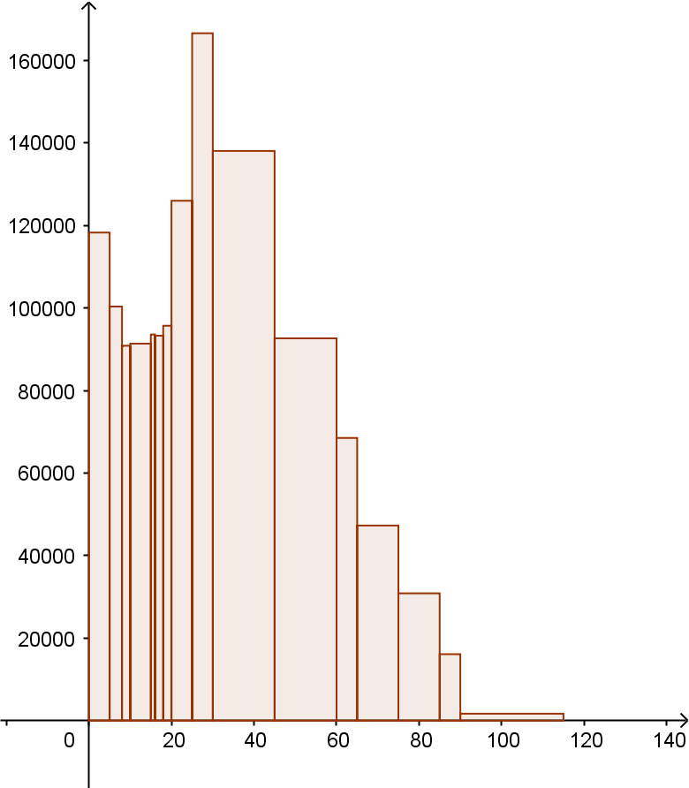
Age Structure in London 2001
Age Structure in London 2011
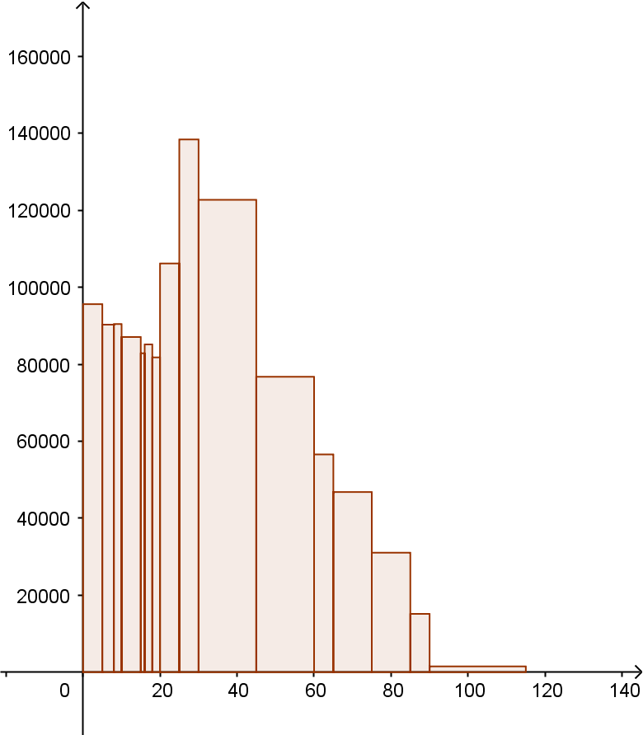

Large Data Set Starter Activity 9

Mean - Median
In the ‘Age Structure by LA 2011’ data set the mean and median age has been given for each Local Authority.
When you subtract the median from the mean you sometimes get a positive number and sometimes a negative.
On the next page you can see the ten Local Authorities with the largest negative difference, the ten with the largest positive difference and the five with no difference (to 1 significant figure).

- What can you say about the distribution of ages in each of the Local Authorities in these tables?
- Can you deduce or infer anything about the Local Authorities? How could you confirm your statements?

10 Largest Negative Mean - Median
North Norfolk | -3.5
West Somerset | -3.3
East Lindsey | -3.2
Rother | -2.8
West Dorset | -2.8
South Hams | -2.7
South Lakeland | -2.6
Craven | -2.5
Hambleton | -2.5
Derbyshire Dales | -2.5

10 Largest Positive Mean - Median
Oxford | 5.3
Nottingham | 4.8
Cambridge | 4.6
Manchester | 4.2
Southampton | 4.1
Newcastle upon Tyne | 3.9
Leicester | 3.8
Islington | 3.5
Bristol, City of | 3.5
Cardiff | 3.5

5 with no difference
Richmondshire | 0
Oadby and Wigston | 0
Rugby | 0
St Edmundsbury | 0
Epsom and Ewell | 0

